1 | Haut du formulaire  Bas du formulaire
  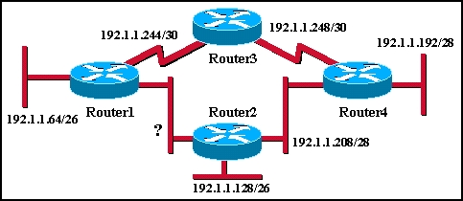
  An additional subnet is required for a new Ethernet link between Router1 and Router2 as shown in the diagram. Which of the following subnet addresses can be configured in this network to provide a maximum of 14 useable addresses for this link while wasting the fewest addresses?
   | 192.1.1.16/26
   | 192.1.1.96/28
   | 192.1.1.160/28
   | 192.1.1.196/27
   | 192.1.1.224/28
   | 192.1.1.240/28
2 | Haut du formulaire  Bas du formulaire
  Which of the following statements are true regarding RIP v1 and v2? (Choose three.)
   | Both RIP versions use hop count.
   | Both RIP versions can provide authentication of update sources.
   | Both RIP versions use 16 hops as a metric for infinite distance.
   | RIP v1 uses split horizon to prevent routing loops while RIP v2 does not.
   | RIP v1 uses hold-down times to prevent routing loops while RIP v2 does not.
   | RIP v1 broadcasts routing table updates, while RIP v2 multicasts its updates.

3 | Haut du formulaire  Bas du formulaire
  A new network is to be configured on a router. Which of the following tasks must be completed to configure this interface and implement dynamic IP routing for the new network? (Choose three.)
  Select the routing protocol to be configured.
  Assign an IP address and subnet mask to the interface.
  Update the ip host configuration information with the device name and new interface IP address.
  Configure the routing protocol with the new network IP address.
  Configure the routing protocol with the new interface IP address and subnet mask.
  Configure the routing protocol in use on all other enterprise routers with the new network information.
4 | Haut du formulaire  Bas du formulaire
  What is the default network mask for a Class B address?
  255.0.0.0
  255.255.0.0
  255.255.255.0
  255.255.255.255

5 | Haut du formulaire  Bas du formulaire
  Which of the following problems does VLSM help to alleviate?
  the shortage of IP addresses
  the difficulty of assigning static IP addresses to hosts in large enterprises
  the complexity of implementing advanced routing protocols such as OSPF and EIGRP
  the shortage of network administrators qualified in the use of RIP v1 and IGRP
6 | Haut du formulaire  Bas du formulaire
  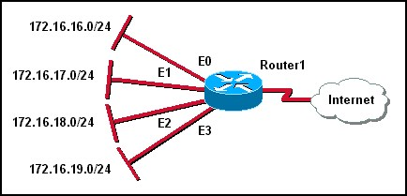
  Refer to the network shown. How will Router1 summarize and advertise the four networks attached to its Ethernet ports?
  172.16.16.0/20
  172.16.19.0/20
  172.16.16.0/20 and 172.16.19.0/20
  172.16.16.0/22
  172.16.18.0/24
  172.16.0.0/24

7 | Haut du formulaire  Bas du formulaire
  Which of the following is considered a limitation of RIP v1?
  RIP v1 does not send subnet mask information in its updates.
  RIP v1 is not widely supported by networking hardware vendors.
  RIP v1 consumes excessive bandwidth by multicasting routing updates using a Class D address.
  RIP v1 requires enhanced router processors and extra RAM to function effectively.
  RIP v1 does not support load balancing across equal-cost paths.
  RIP v1 authentication is complicated and time-consuming to configure.
8 | Haut du formulaire  Bas du formulaire
  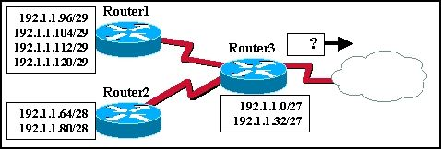
  The routers in the diagram use the subnet assignments shown. What is the most efficient route summary that can be configured on Router3 to advertise the internal networks to the cloud?
  192.1.1.0/26 and 192.1.1.64/27
  192.1.1.128/25
  192.1.1.0/23 and 192.1.1.64/23
  192.1.1.0/24
  192.1.1.0/25
  192.1.1.0/24 and 192.1.1.64/24

9 | Haut du formulaire  Bas du formulaire
  A Class C network address has been subnetted into eight subnetworks. Using VLSM, the last subnet will be divided into eight smaller subnetworks. What bit mask must be used to create eight smaller subnetworks, each having two usable host addresses?
  /26
  /27
  /28
  /29
  /30
  /31
10 | Haut du formulaire  Bas du formulaire
  Which command would a network administrator use to determine if the routers in an enterprise have learned about a newly added network?
  router# show ip address
  router# show ip route
  router# show ip networks
  router# show ip interface brief
  router# debug ip protocol
  router# debug rip update

11 | Haut du formulaire  Bas du formulaire
  How does a router know of paths to destination networks? (Choose two.)
  inspection of the destination IP address in data packets
  ARP requests from connected routers
  manual configuration of routes
  updates from other routers
  DHCP information broadcasts
  updates from the SMTP management information base
12 | Haut du formulaire  Bas du formulaire
  Which of the following are contained in the routing updates of classless routing protocols? (Choose two.)
  32-bit address
  next hop router interface
  subnet mask
  unicast host address
  Layer 2 address

13 | Haut du formulaire  Bas du formulaire
  Which subnet mask is represented by the /21 notation?
  255.255.224.0
  255.255.248.0
  255.255.252.0
  255.255.240.0
14 | Haut du formulaire  Bas du formulaire
  What does VLSM allow a network administrator to do?
  utilize one subnet mask throughout an autonomous system
  utilize multiple subnet masks in the same IP address space
  utilize IGRP as the routing protocol in an entire autonomous system
  utilize multiple routing protocols within an autonomous system

15 | Haut du formulaire  Bas du formulaire
  How often does RIP v1 send routing table updates, by default?
  every 30 seconds
  every 45 seconds
  every 60 seconds
  every 90 seconds
16 | Haut du formulaire  Bas du formulaire
  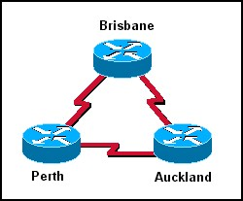
  In the network shown in the graphic, three bits were borrowed from the host portion of a Class C address. How many valid host addresses will be unused on the three point-to-point links combined if VLSM is not used?
  3
  4
  12
  36
  84
  180
17 | Haut du formulaire  Bas du formulaire
  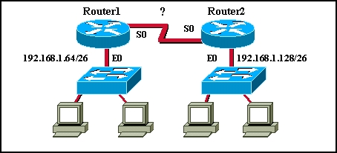
  Router1 and Router2 shown in the topology have been configured with the no ip subnet-zero command. Which of the following valid VLSM network numbers could be used for the serial link between Router1 and Router2? (Choose two.)
  192.168.1.0/30
  192.168.1.4/30
  192.168.1.8/30
  192.168.1.96/30
  192.168.1.138/30
  192.168.1.190/30

18 | Haut du formulaire  Bas du formulaire
  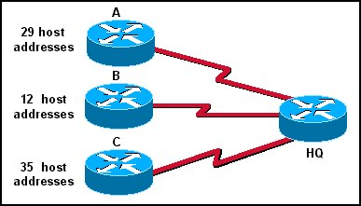
  A Class C address has been assigned for use in the network shown in the graphic. Using VLSM, which bit mask should be used to provide for the number of host addresses required on Router A, while wasting the fewest addresses?
  /31
  /30
  /29
  /28
  /27
  /26
19 | Haut du formulaire  Bas du formulaire
  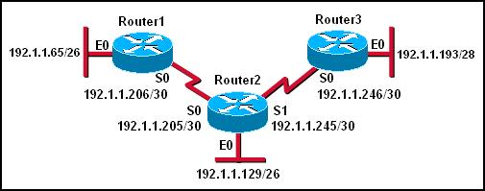
  The network shown in the diagram is having problems routing traffic. It is suspected that the problem is with the addressing scheme. What is the problem with the addressing used in the topology?
  The address assigned to the Ethernet0 interface of Router1 is a broadcast address for that subnetwork.
  The subnetwork configured on the serial link between Router1 and Router2 overlaps with the subnetwork assigned to Ethernet0 of Router3.
  The subnetwork assigned to the Serial0 interface of Router1 is on a different subnetwork from the address for Serial0 of Router2.
  The subnetwork assigned to Ethernet0 of Router2 overlaps with the subnetwork assigned to Ethernet0 of Router3.

20 | Haut du formulaire  Bas du formulaire
  What is the purpose of the network command used in the configuration of the RIP routing protocol?
  It specifies RIP v2 as the routing protocol.
  It enables the use of VLSM.
  It specifies the fastest path to the destination route.
  It specifies which interfaces will exchange RIP routing updates.
  It activates RIP for all routes that exist within the enterprise network.

